**ASSIGNMENT 2 FRONT SHEET**

|  |  |  |  |
| --- | --- | --- | --- |
| **Qualification** | **TEC Level 5 HND Diploma in Computing** | | |
| **Unit number and title** | **Unit 43: Internet of Things** | | |
| **Submission date** |  | **Date Received 1st submission** |  |
| **Re-submission Date** |  | **Date Received 2nd submission** |  |
| **Student Name** | Nguyễn Trọng Duy | **Student ID** | GCD17313 |
| **Class** |  | **Assessor name** |  |
| **Student declaration**  I certify that the assignment submission is entirely my own work and I fully understand the consequences of plagiarism. I understand that making a false declaration is a form of malpractice. | | | |
|  |  | **Student’s signature** | Duy |

**Grading grid**

|  |  |  |  |  |  |  |
| --- | --- | --- | --- | --- | --- | --- |
| P5 | P6 | P7 | M5 | M6 | D3 | D4 |
|  |  |  |  |  |  |  |

|  |  |  |
| --- | --- | --- |
| **❒ Summative Feedback: ❒ Resubmission Feedback:** | | |
| **Grade:** | **Assessor Signature:** | **Date:** |
| **Internal Verifier’s Comments:** | | |
| **Signature & Date:** | | |

|  |
| --- |
| **Assignment Brief and Guidance:** |
| You currently work as a product developer for a company manufacturing IoT products. The government of your hometown city wants to build the city as a smart one. They need to collect the data from environment in this city, do insight the data then give out some controlling decisions. Your company take the responsibility to make a demo product. As part of your role, your manager has tasked you to plan and develop a new IoT system. This system will collect some environment information such as: air quality, water level, rain level, humidity, … from IoT devices, save to a database, and then a smart application will do some analysis and make controlling decision.  **Part 1 (Assignment 1)**: For the first part, you must:   * Investigate a specific IoT platform for the project. * Plan an IoT system with the chosen platform. This plan will be in the form of a document and will include supporting evidence and material. * Evaluate your plan and the challenge in your solution.   **Part 2 (Assignment 2)**: For the second part, you must:   * Show evidence about Developed IoT application using any combination of hardware, software, data, platforms and services (video or images of your IoT system with code snippet) * Evaluate your IoT application and detail the problem your IoT application solves, the potential impact on people, business, society and the end user and the problems it might encounter when integrating into the wider IoT ecosystem |
| **Assignment Brief and Guidance:** |
| You currently work as a product developer for a company manufacturing IoT products. The government of your hometown city wants to build the city as a smart one. They need to collect the data from environment in this city, do insight the data then give out some controlling decisions. Your company take the responsibility to make a demo product. As part of your role, your manager has tasked you to plan and develop a new IoT system. This system will collect some environment information such as: air quality, water level, rain level, humidity, … from IoT devices, save to a database, and then a smart application will do some analysis and make controlling decision.  Part 1 (Assignment 1): For the first part, you must:   * Investigate a specific IoT platform for the project. * Plan an IoT system with the chosen platform. This plan will be in the form of a document and will include supporting evidence and material. * Evaluate your plan and the challenge in your solution.   Part 2 (Assignment 2): For the second part, you must:   * Show evidence about Developed IoT application using any combination of hardware, software, data, platforms and services (video or images of your IoT system with code snippet) * Evaluate your IoT application and detail the problem your IoT application solves, the potential impact on people, business, society and the end user and the problems it might encounter when integrating into the wider IoT ecosystem |

|  |  |  |
| --- | --- | --- |
| Learning Outcomes and Assessment Criteria | | |
| Pass | Merit | Distinction |
| **LO3** Develop an IoT application using any combination of hardware, software, data, platforms and services. | | |
| **P5** Employ an appropriate set of tools to develop your plan into an IoT application.  **P6** Run end user experiments then identify the perfect and incomplete points in your system. | **M5** Reconcile and evaluate end user feedback and determine advantages and disadvantages of your chosen IoT techniques. | **D3** Critical evaluate security risks that your application might encounter. |
| **LO4** Evaluate your IoT application and detail the problem your IoT application solves, the potential impact on people, business, society and the end user and the problems it might encounter when integrating into the wider IoT ecosystem | | |
| **P7** Discuss the drawback in your system and solutions for improving. | **M6** Undertake a critical review original plan and give out the improving plan. | **D4** Critique the overall success of your application. Did it solve your problem? What is the potential impact on people, business, society and the end user? What problems might it encounter when integrating into the wider IoT ecosystem? |

# Table of content

Contents

Table of content 6

**_LO3** Develop an IoT application using any combination of hardware, software, data, platforms and services. 8

**P5** Employ an appropriate set of tools to develop your plan into an IoT application. 8

-Introduce your problem and how to solve it by IoT platform including the reason and the schematic for your solution 8

-My problem: 8

-Flow: 8

-Project: 8

Give out for your selection an appropriate set of tools, frameworks, devices for your solution 13

-Tool 13

-Frameworks 17

-Device 17

-Develop your solution, write down your sketch and upload it on your devices. 20

- Desired result: Turn the water pump on and off 20

Blynk Cloud 21

Real Devices IOT 22

Blynk (on Moblie) 22

Design Model 30

Database FireBase 31

Step by Step 32

**P6** Run end user experiments and examines feedback. 38

**Run test application** in the real world and get feedback , Supply **evidence image** for this 38

Examine the feedback: which are good points, which are not? Explain for some not good points 40

-Good 41

-Not good 41

**_LO4** Evaluate your IoT application and detail the problem your IoT application solves, the potential impact on people, business, society and the end user and the problems it might encounter when integrating into the wider IoT ecosystem 41

**P7** Evaluate end user feedback from your IoT application. 41

User feedback 41

Evaluate end user feedback from your IoT application 45

+ how does your IoT meet the requirements 45

System requirement 46

How this IOT Stuff affect us life 46

+ Feasibility (including technical, economy, and organization feasiblity) 46

+ Ability to improve 47

Conclusion 47

# **_LO3** Develop an IoT application using any combination of hardware, software, data, platforms and services.

# **P5** Employ an appropriate set of tools to develop your plan into an IoT application.

## -Introduce your problem and how to solve it by IoT platform including the reason and the schematic for your solution

### -My problem:

I current work as a product developer for a new startup where I design IOT product to plan and develop a new Iot Product, service or application for a potental client

Plant need better Soltution to Grow Faster  
In this case, by Give out your idea about any IoT application used for solving any problem in real world

With this user and include this feedback into multiple iterative versions of my product

Make a plant watering system Application by checking soil & air moisture through the Internet By using:

### -Flow:

**ESP 🡪 Sensor dht11 arduino, Relay 5V, Mini PUMP 🡪 Internet -> Blynk ->FireBase**

### -Project:

-> Use ESP to ‘control + WIFI’

-> Sensor dht11 arduino (Test humidity- crop temperature), Sensor Servo SG90 (Activate pump

-> Relay 5V (Water Pump On/Off Control) + separate USB power supply for… Mini Pump (Watering plants)

-> Blynk controlled by Internet

-> FireBase generates DATABASE

#### Sersor:

#### Dht11 arduino

For read the temperature - humidity from the sensor and output is data

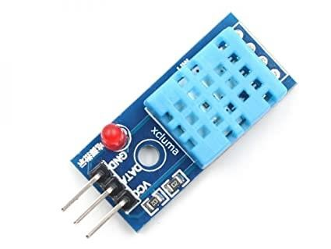 (xcluma, n.d.)

#### Relay 5V

For turn on off MINI- PUMP

(https://iotmaker.vn/relay-1-kenh-5v.html, n.d.)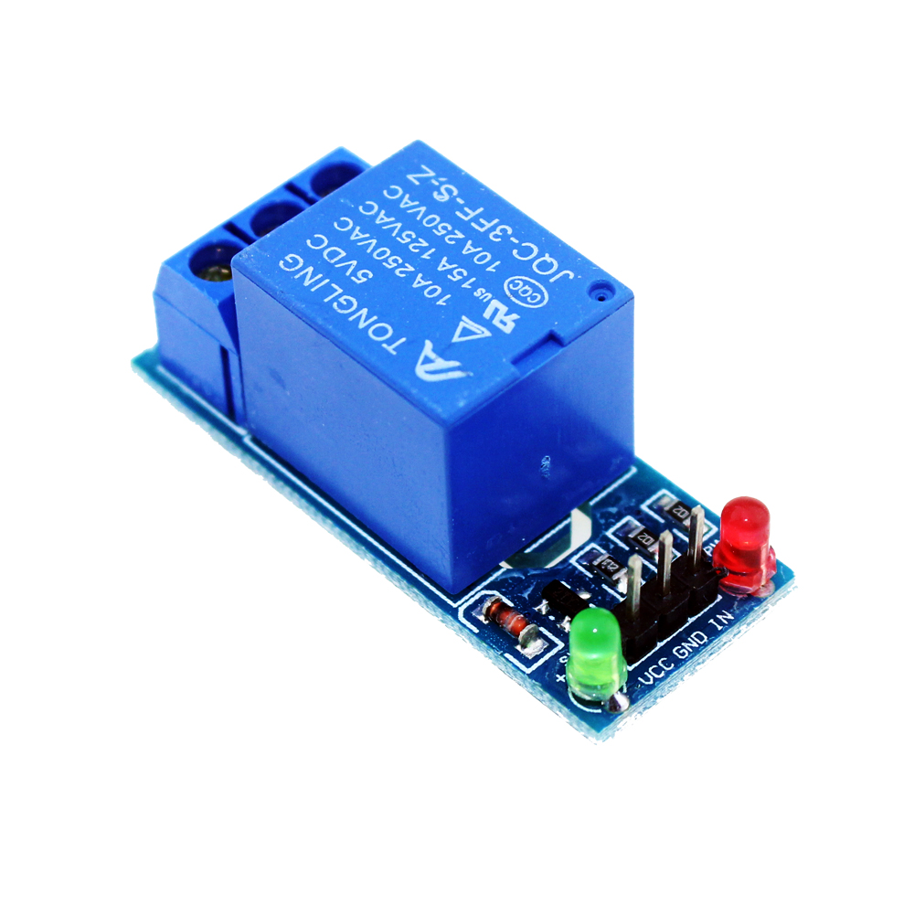

#### Mini PUMP

Pump water to plant tree

(https://www.flipkart.com/india-iot-shop-submersible-water-pump-motor-mini-micro-dc-3-4-5v-low-noise-brushless-temperature-sensor-controller-electronic-hobby-kit/p/itmffwxn2rxpwzzv, n.d.)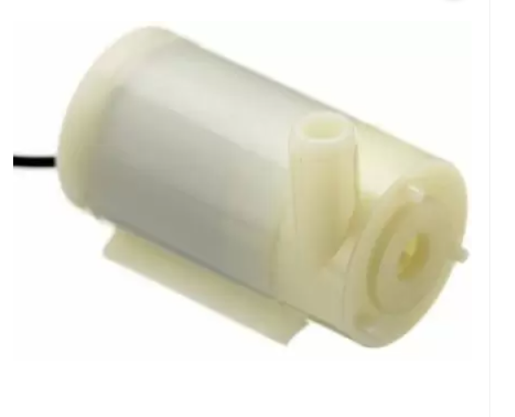

-how to solve it by Reason

## Give out for your selection an appropriate set of tools, frameworks, devices for your solution

### -Tool

#### Blynk APP

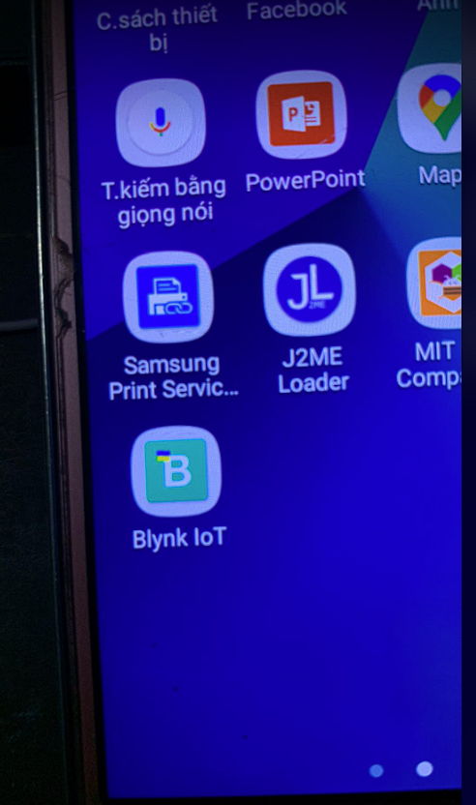

#### Adruidno Software

For coding

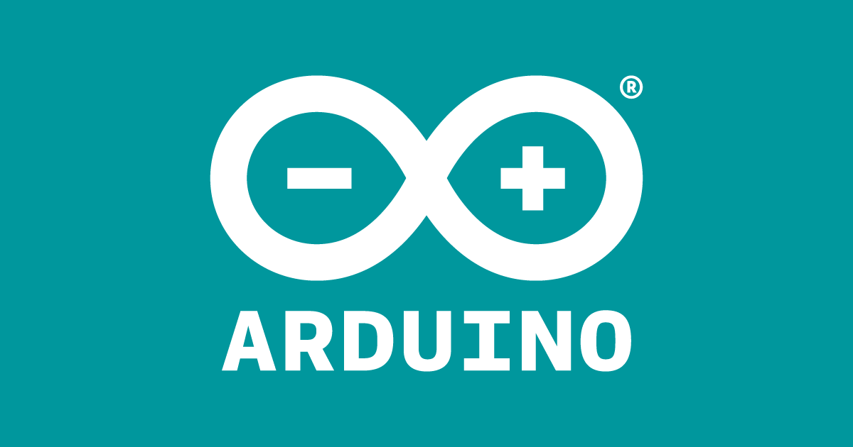

#### FireBase

PUSH DELETE Datas with JSON with REST API provide by Google

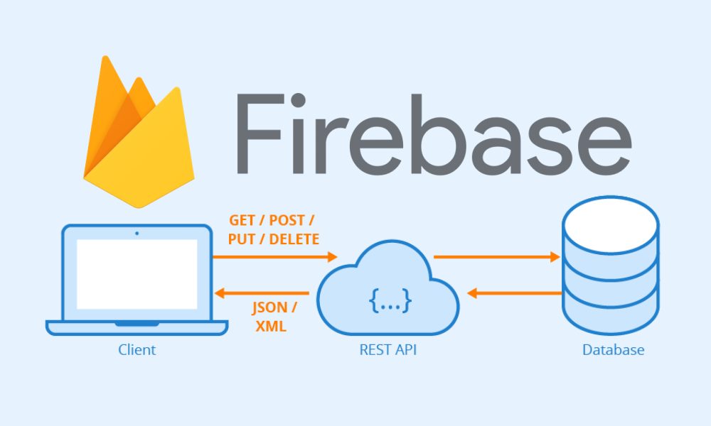

### -Frameworks

#### FireBase

(https://firebase.google.com/docs/cloud-messaging/fcm-architecture, n.d.)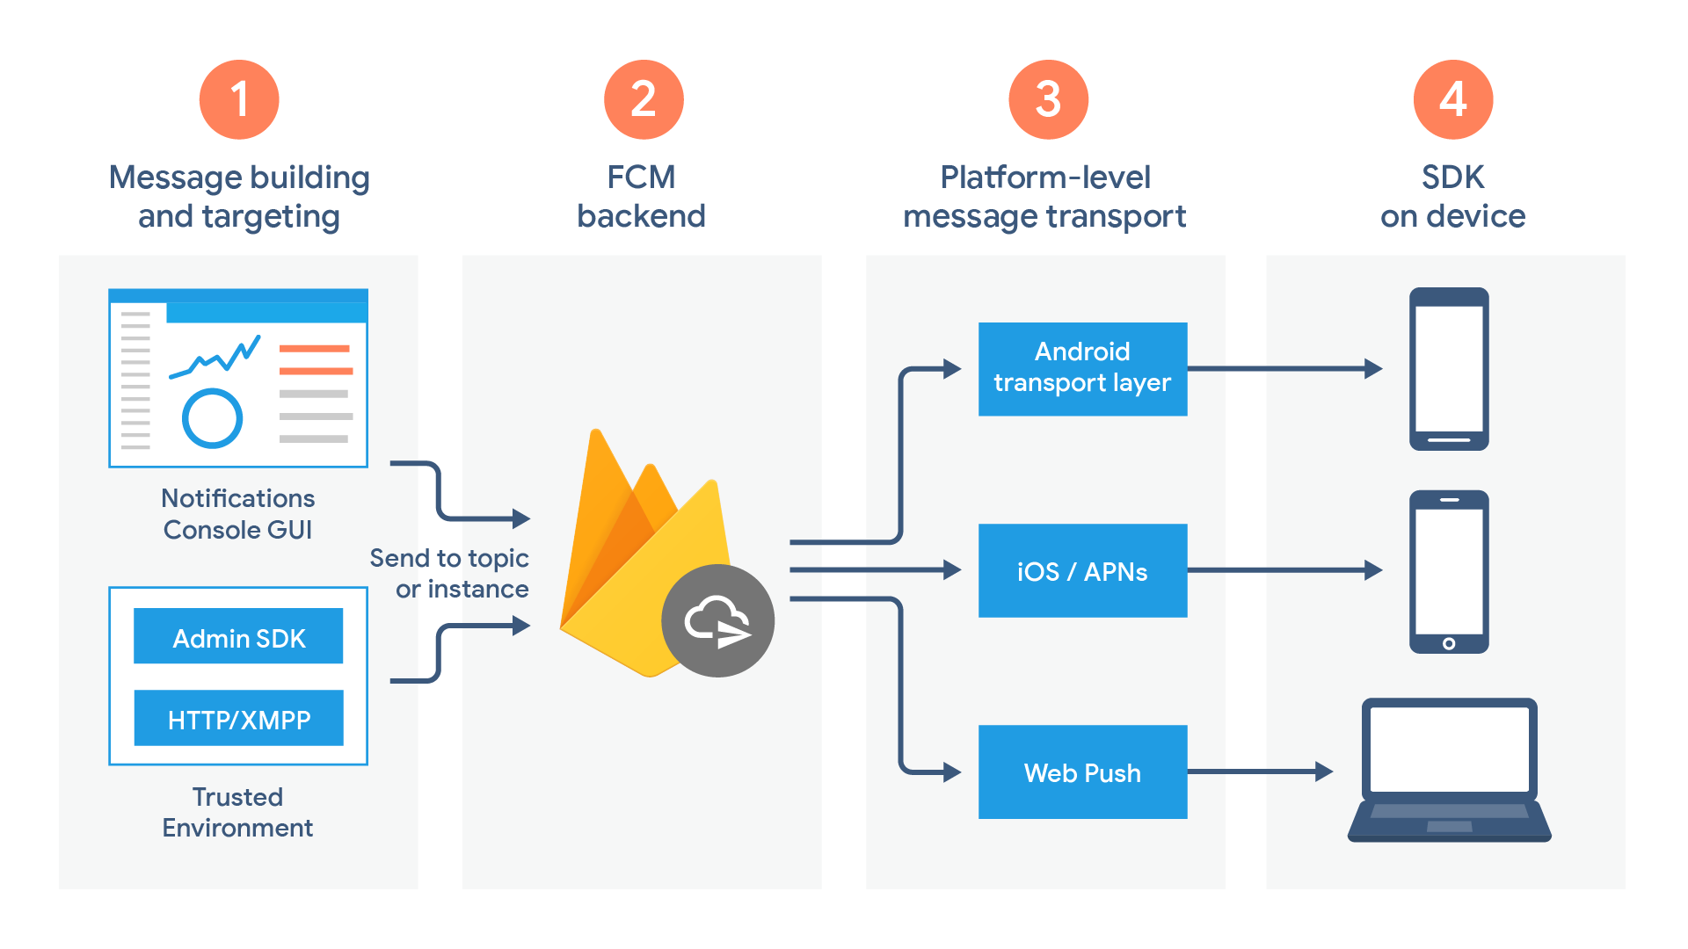  
DateBase get Datas from ESP8266 Arduino

### -Device

#### Sensor dht11 arduino

For read the temperature - humidity from the sensor and output is data

 (xcluma, n.d.)

#### Sensor Servo SG90

For control the output water with the IOT application

(htt)

#### Relay 5V

For turn on off MINI- PUMP

(https://iotmaker.vn/relay-1-kenh-5v.html, n.d.)

#### Mini PUMP

Pump water to plant tree

(https://www.flipkart.com/india-iot-shop-submersible-water-pump-motor-mini-micro-dc-3-4-5v-low-noise-brushless-temperature-sensor-controller-electronic-hobby-kit/p/itmffwxn2rxpwzzv, n.d.)



## -Develop your solution, write down your sketch and upload it on your devices.

## - Desired result: Turn the water pump on and off

Blynk::

-toggle (ON OFF) relay = toggle state change

What is the input = just run, the low relay output is 0v, the input high is 3V

High=off, low=pump open

see initial state - change logic level of pins D1 and D8,

change output pin=0v to 3.3v and vice versa

*Emulator in real life :

Opening and closing 1 electrical appliance 220V AC

DH11::

DHT measure humidity temperature

Esp will pass this data to firebase

-need extra code AUTOMATIC water the Tree

If (humidity > 45)

{relay on}

Solution:

### Blynk Cloud

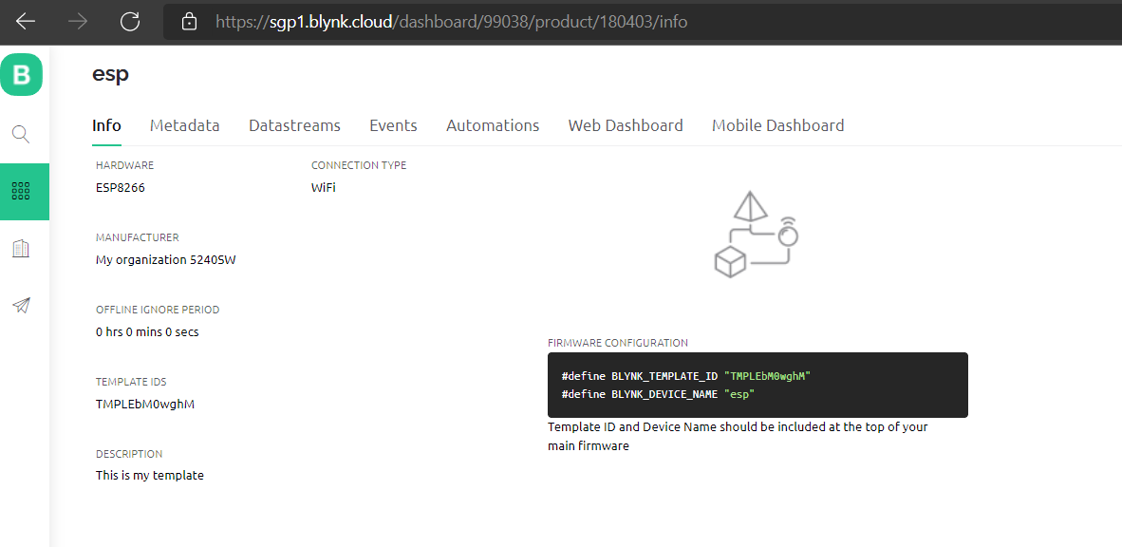

### Real Devices IOT

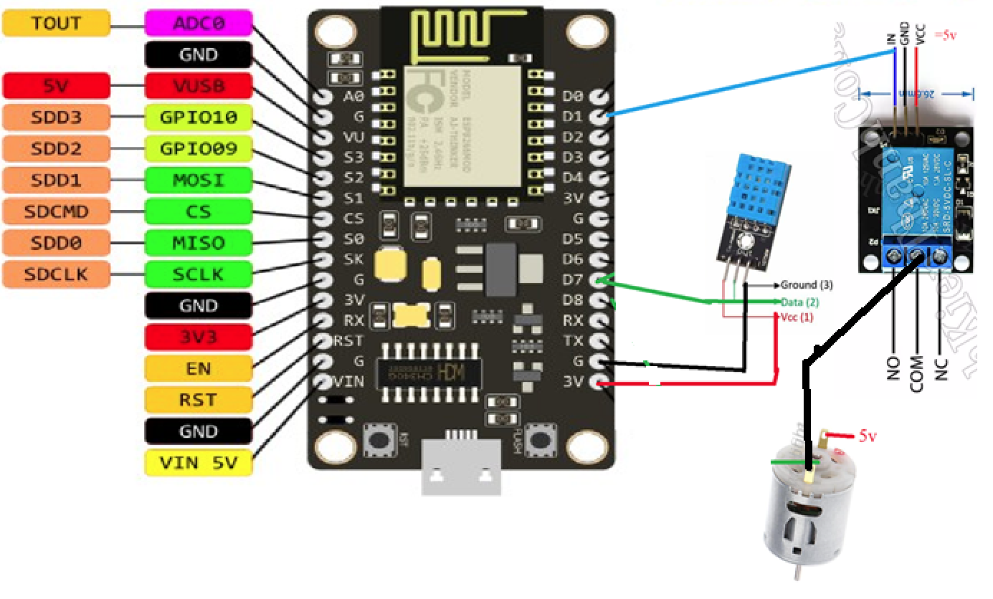

-Generally

Wire VCC= Positive

GND= negative

DATA= connect D1 D7

-The positive and negative wires (2 wires) plug 1 side into 1 source

Red common 1 positive circuit USB SUPPLY USB

Black common 1 negative circuit USB SUPPLY USB

-The data wire is on the Board

### Blynk (on Moblie)

#### Step by Step

Download Blynk from Apple AppStore or Google Play Store

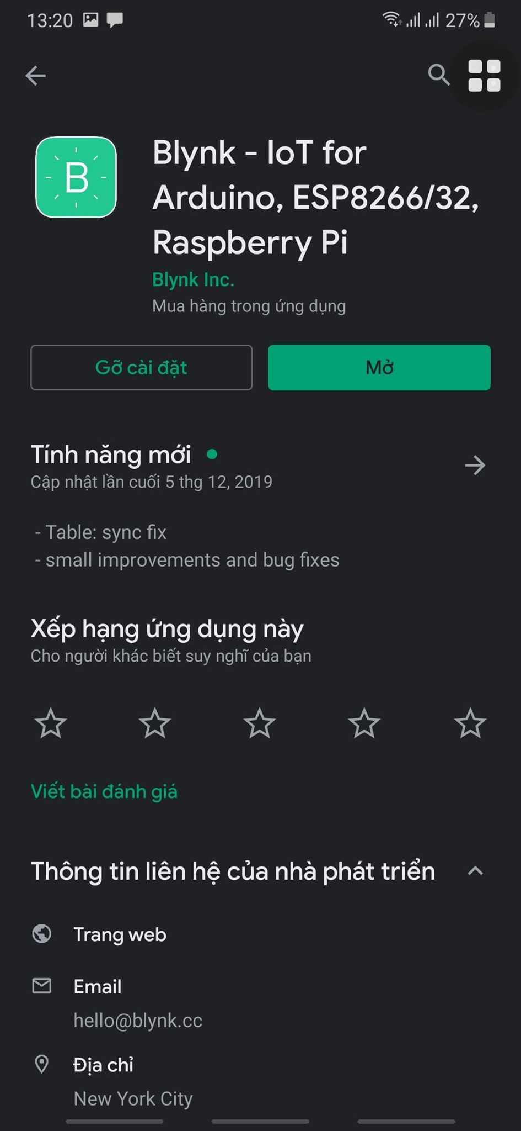

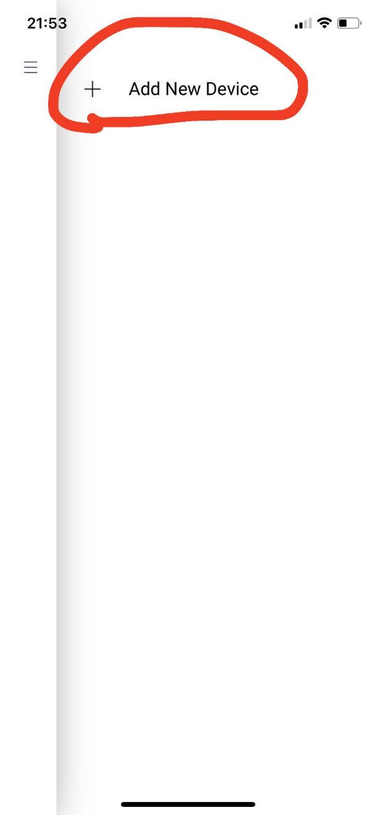

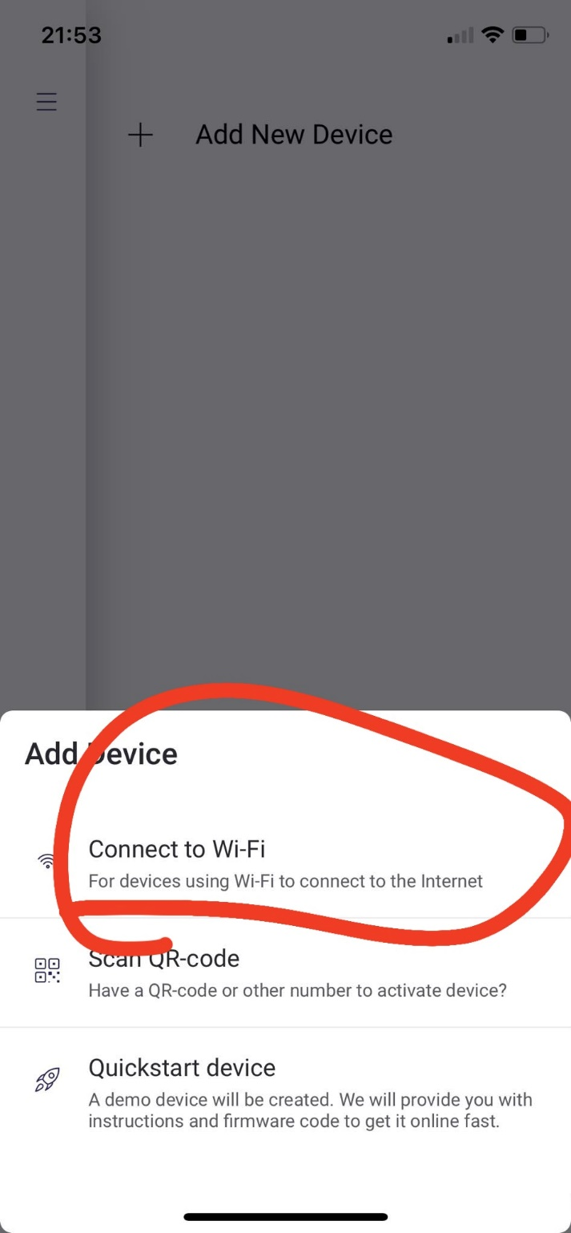

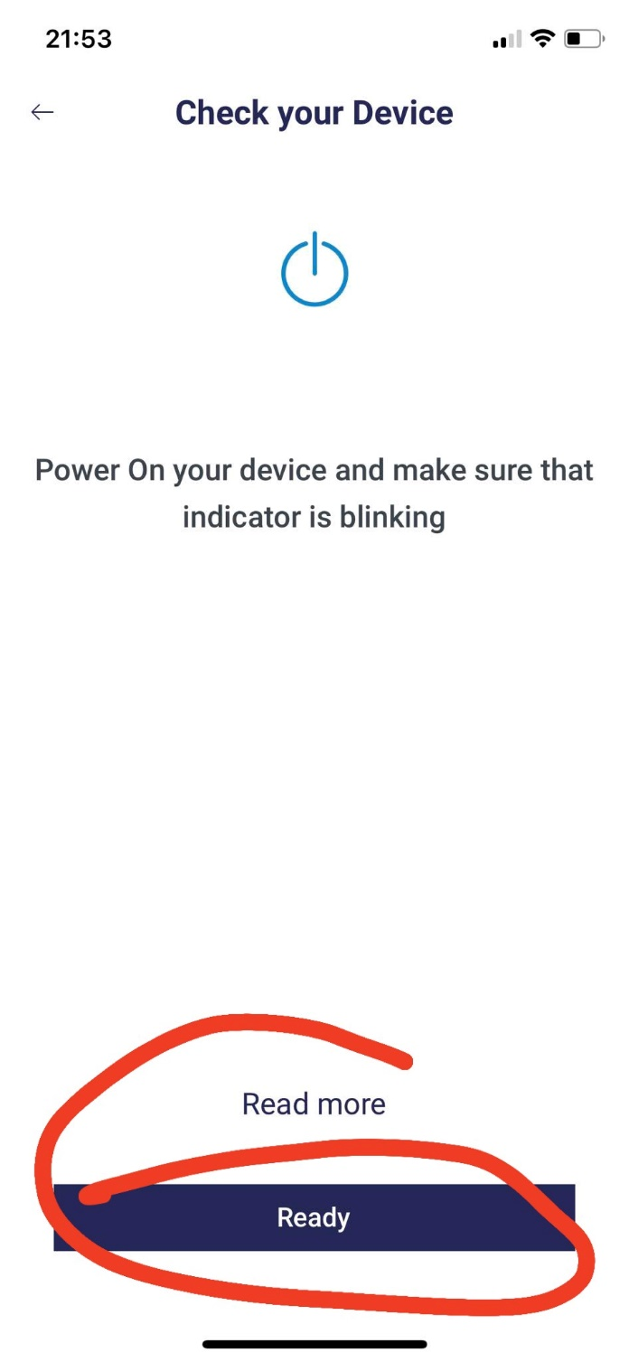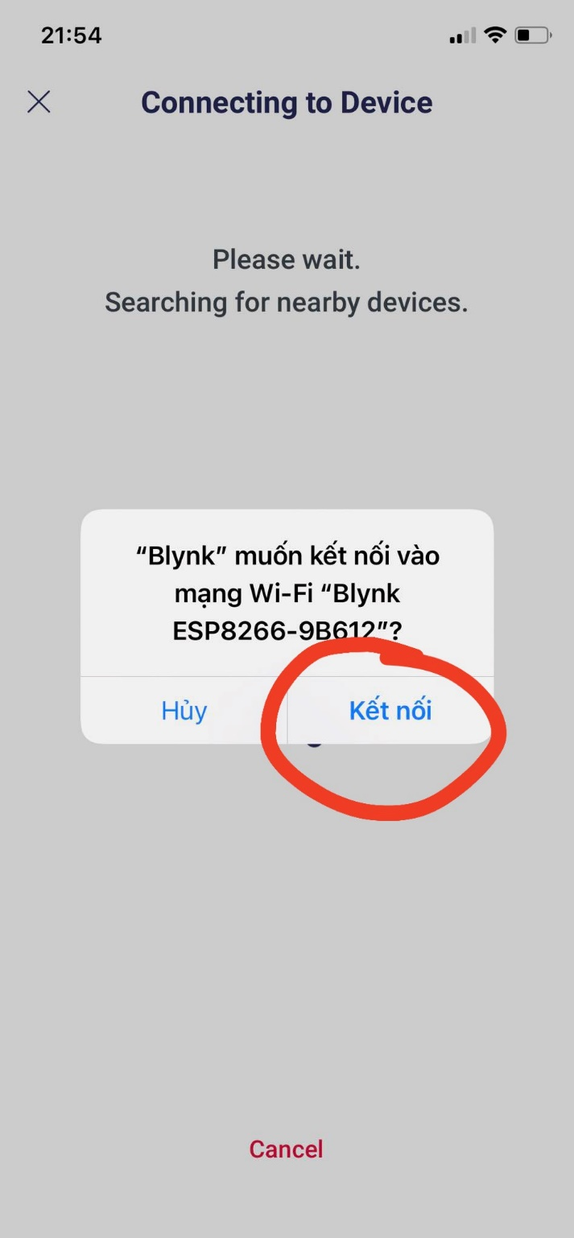**sa**

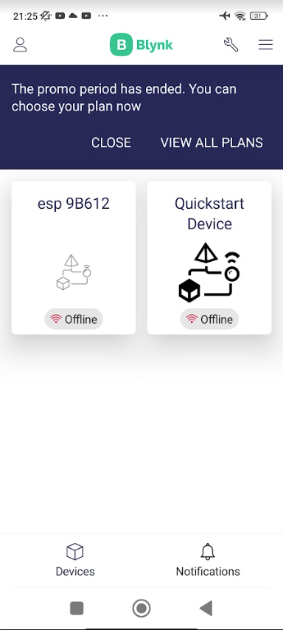

**Click ON OFF Relay for CONTROL PUMP !!**

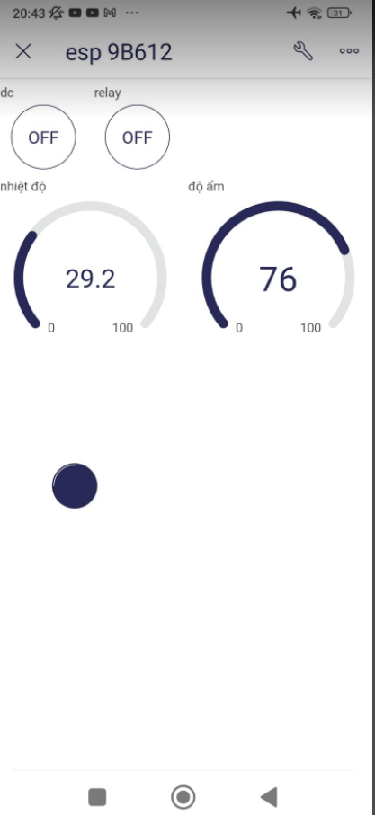

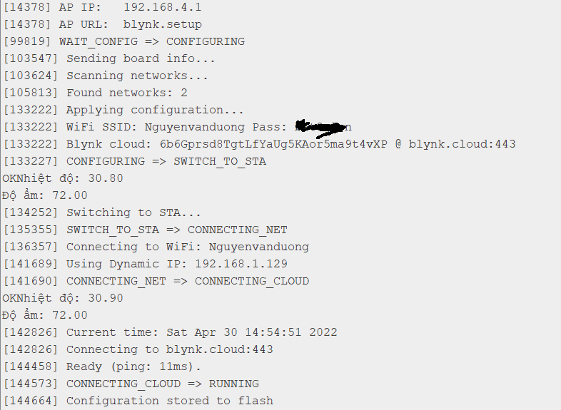

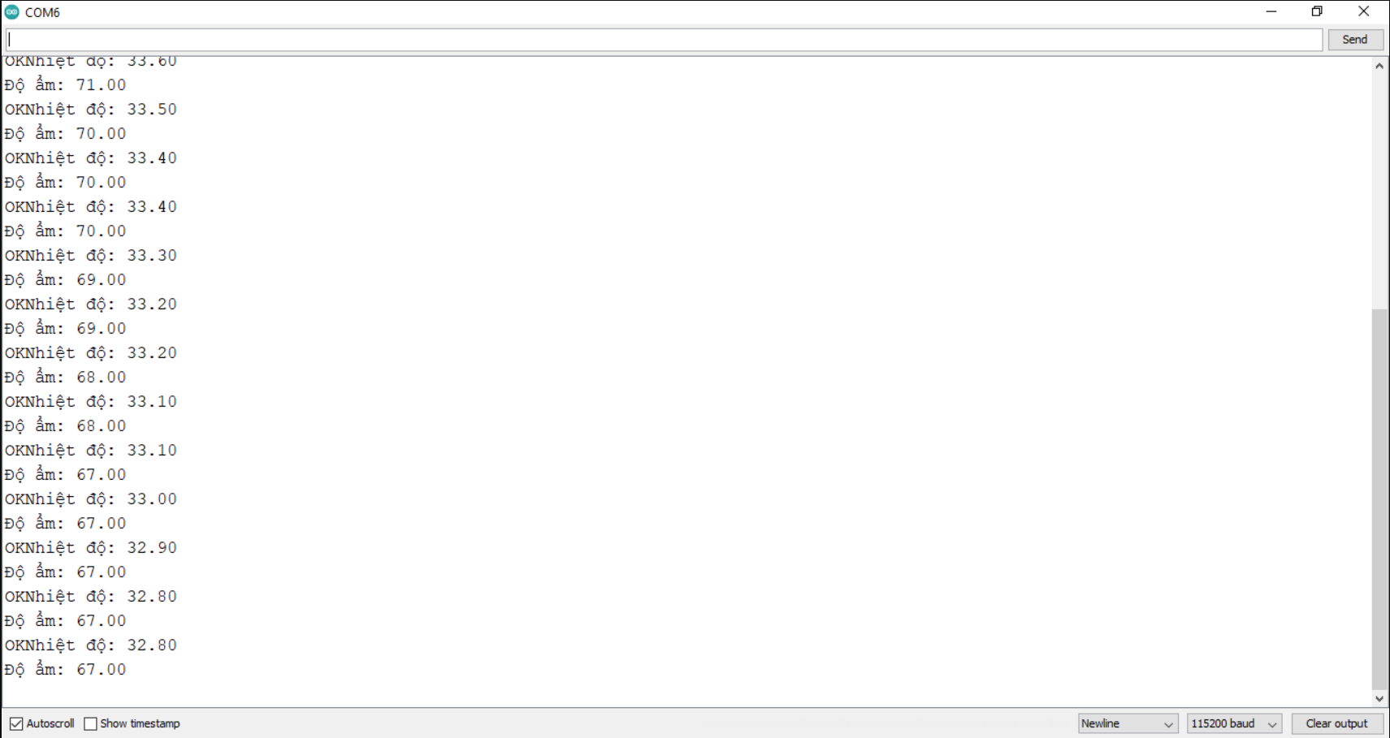

### Design Model

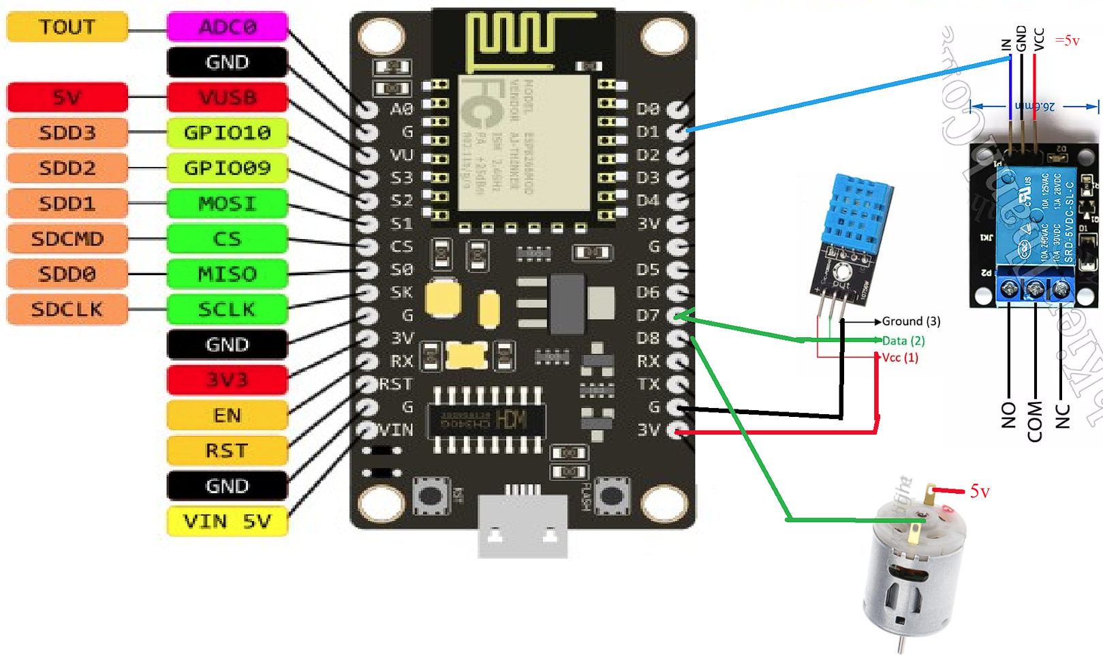

Need 5V USB output for Relay and Mini PUMP (Because ESP8266 not enough power for them)

### Database FireBase

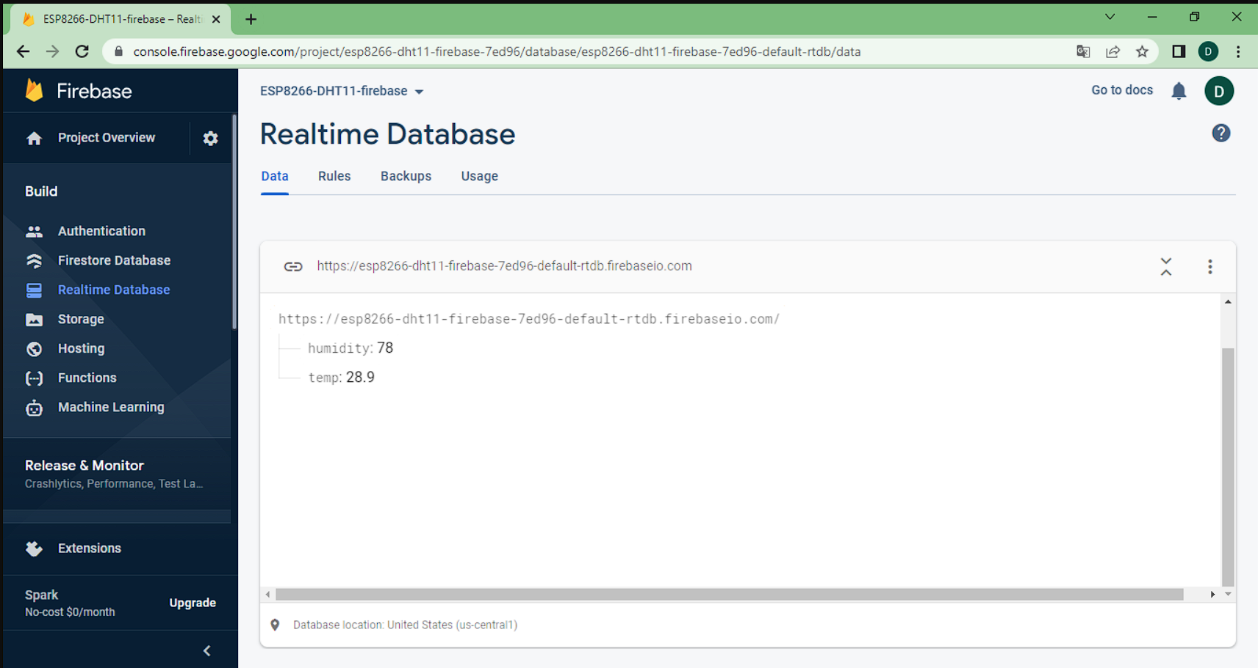

### Step by Step

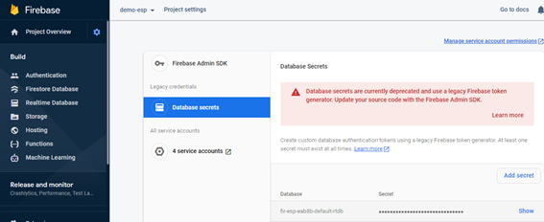 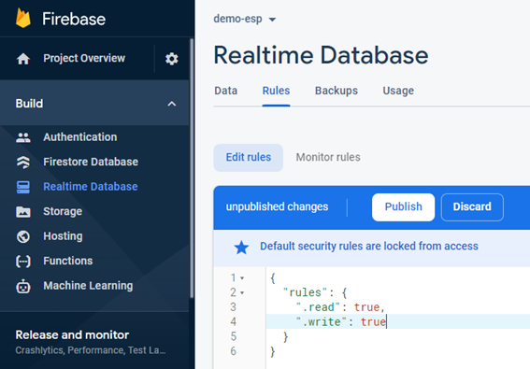   
-Write down your sketch

Need Custom Library at here [Edgent_ESP8266_LCD_DHT11.zip - Google Drive](https://drive.google.com/file/d/1J0ksPhYIFglizTcrSwuCgLjOhvqk6VXE/view)

**Code:**

#define BLYNK_TEMPLATE_ID "TMPLEbM0wghM" // mã ID tài khoản Blynk

#define BLYNK_DEVICE_NAME "esp"

//khai báo các thư viện DHT, FIREBASE...

#include "DHTesp.h"

#include <Wire.h>

#include "FirebaseESP8266.h"

#include <ESP8266WiFi.h>

#include <ArduinoJson.h>

#define BLYNK_FIRMWARE_VERSION "0.1.0"

#define BLYNK_PRINT Serial

#define APP_DEBUG

#define USE_NODE_MCU_BOARD

#include "BlynkEdgent.h"

#define led1 D1 // chân đầu ra 1 relay

#define led2 D8 // chân đầu ra 2 bơm

#define button1 D5 //chân phím cơ 1

#define button2 D2 //chân phím cơ 2

FirebaseData firebaseData; // Data firebase

boolean bt1_state=HIGH; // trạng thái phím 1

boolean bt2_state=HIGH; // trạng thái phím 2

DHTesp dht;

String path ="/";

float t,h;

BlynkTimer timer;

WidgetLED led(V0);// led connect

boolean blynkState=0;// trạng thái blynk

void setup(){

Serial.begin(115200);

delay(100);

pinMode(led1, OUTPUT); // khai báo 2 chân tín led1 led2 là đầu ra

pinMode(led2, OUTPUT);

pinMode(button1,INPUT_PULLUP);// khai báo 2 phím là tín hiệu đầu vào

pinMode(button2,INPUT_PULLUP);

digitalWrite(led2,HIGH); // trạng thái led 2 = 0 (mức thấp)relay cao high= low

digitalWrite(led1,HIGH); // trạng thái led 2 = 0 (mức thấp)relay cao high= low

BlynkEdgent.begin();

//dht.begin();

dht.setup(13, DHTesp::DHT11); // chân DHT là 13(D7)

timer.setInterval(3000,readSensor); // timer đọc dữ liệu cảm biến

timer.setInterval(1000,updateBlynk);// timer update dữ liệu

Firebase.begin("dht11-d796a-default-rtdb.firebaseio.com","0RwTbz0Lt5yFJnGlnxSrQp9qRps2GDjuqUanNek0");// địa chỉ web và mã bảo mật

Firebase.reconnectWiFi(true); // tự động kết nối lại wifi

if(!Firebase.beginStream(firebaseData,path))

{

Serial.println("REASON"+ firebaseData.errorReason() );

Serial.println();

}

}

void loop(){

BlynkEdgent.run(); // gọi các chương trình con vào làm việc

timer.run();

if(Blynk.connected()){

if(blynkState==0){

blynkState=1;

}

}

check_button();

senddata();

}

BLYNK_WRITE(V3){ // phím nhấn trên app Blynk IOT 2.0

int p = param.asInt();

digitalWrite(led1, p);

}

BLYNK_WRITE(V4){// phím nhấn trên app Blynk IOT 2.0

int p = param.asInt();

digitalWrite(led2, p);

}

void readSensor(){

float h_temp = dht.getHumidity(); // biến lưu độ ẩm

float t_temp = dht.getTemperature();// biến lưu nhiệt độ

Serial.print(dht.getStatusString());

if (isnan(h_temp) || isnan(t_temp)) { /// nếu ko đọc được giá trị nhiệt độ hoặc độ ẩm serial báo lỗi

Serial.println("Failed to read from DHT sensor!");

//return;

}else{

h = h_temp;// nhiệt độ

t = t_temp;//độ ẩm

Serial.print("Nhiệt độ: "); Serial.println(t);// in lên cổng serial

Serial.print("Độ ẩm: "); Serial.println(h);

}

if(t>40)

{

digitalWrite(led2,LOW);

}

}

void updateBlynk(){

if (led.getValue()) {// update dữ liệu led connect

led.off();

} else {

led.on();

}

Blynk.virtualWrite(V1,t); //nhiệt độ

Blynk.virtualWrite(V2,h);//độ ẩm

}

void check_button(){ //kiểm tra phím nhấn Bơm Nước, relay .Bấm trên blynk bật tắt Bơm Nước, relay

if(digitalRead(button1)==LOW){ // nếu phím được nhấn

if(bt1_state==HIGH){// trang thái phím bằng mức cao

digitalWrite(led1,!digitalRead(led1));// trạng thái led1 bằng led1 đảo (0-1, 1-0)

Blynk.virtualWrite(V3,digitalRead(led1));// trang thái trên app bằng trạng thái led

bt1_state=LOW;// trang thái phím bằng mức thấp

delay(200);

}

}else{

bt1_state=HIGH;

}

if(digitalRead(button2)==LOW){

if(bt2_state==HIGH){

digitalWrite(led2,!digitalRead(led2));

Blynk.virtualWrite(V4,digitalRead(led2));

bt2_state=LOW;

delay(200);

}

}else{

bt2_state=HIGH;

}

}

void senddata()

{

Firebase.setFloat(firebaseData, "temp",t); // gửi dữ liệu nhiệt độ lên firebase

Firebase.setFloat(firebaseData, "humidity",h);// gửi dữ liệu độ ẩm lên firebase

delay(1000);

}

The project well meets business needs, so it can deliver and sustain on time, under budget, and achieve the promised business value and return on investment. Many factors influence project success, but strong project management and governance techniques are especially important. This version has worked well in a variety of environments; in the near future, I want to enhance by developing and connecting with the Blynk application.

# **P6** Run end user experiments and examines feedback.

## **Run test application** in the real world and get feedback , Supply **evidence image** for this

|  |  |  |  |  |
| --- | --- | --- | --- | --- |
| Test case | Source | Expected output | Actual output | Result |
| Blynk All Monitoring & Button | Blynk | Show monitoring | Show monitoring | Pass |
| FireBase DataBase | FireBase | Realtime Database | Realtime Database | Pass |
| dht11 serial monitor | DHT11 | dht11 serial monitor | dht11 serial monitor | Pass |
| On-Off Mini Pump through Relay | Sensor Mini Pump | Turn on/ Off Pump via Blynk | Turn on/ Off Pump via Blynk | Pass |







## Examine the feedback: which are good points, which are not? Explain for some not good points

TestCase Mong muốn vs Thực Tế có đạt yêu cầu hay không

### -Good

Everything seem working

### -Not good

Too many wires, take up space, need power to maintain IoT Devices

# **_LO4** Evaluate your IoT application and detail the problem your IoT application solves, the potential impact on people, business, society and the end user and the problems it might encounter when integrating into the wider IoT ecosystem

# **P7** Evaluate end user feedback from your IoT application.

Làm Survey ý kiến khách hàng sử dụng sản phẩm, ưu nhược điểm

## User feedback

Any information gathered from users or customers about their experience using my product or service is referred to as user feedback. This user feedback might be proactive, in which case I ask for it, or reactive, in which case my users provide it without prompting. Feedback can come from a variety of sources and in a variety of formats. Bug reports, help requests, and suggestions for how to enhance my product are examples of many types of feedback. Live chat, in-product surveys, email, phone, and more channels are available.   
After gathering input, multiple teams use it to improve more and more about the user or customer experience.

|  |  |  |  |  |  |  |
| --- | --- | --- | --- | --- | --- | --- |
| Question text from User Feedback survey | Number of responses to question | Scale Used | Sasticfied | Fine | Dislike | Comment |
| DO you think it’s possible to find a product not same as us ? | 100 | 70 | 90% | 6 | 5 | NA |
| What great about our product ? | 250 | 80 | 95% | 4 | 1 | 1 |
| What if you stopping using this today | 1000 | 45 | 78 | 3 | 4 | 6 |
| Main concers about products | 576 | 41 | 30 | 4 | 4 | 5 |
| Do this make your experience better ? | 3243 | 4 | 34 | 3 | 4 | I think there no need to add any featur. Just improve QUANTIY and QUALITY of Service |

When you started our production ?

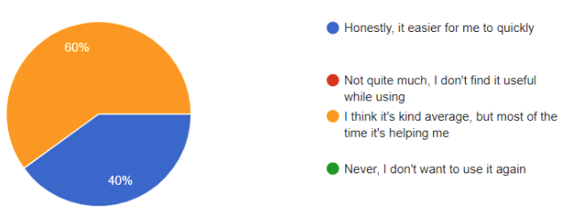

Have you ever use this product before ?

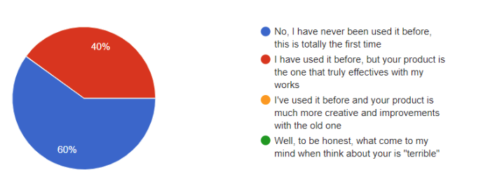

How do you use US product ?   
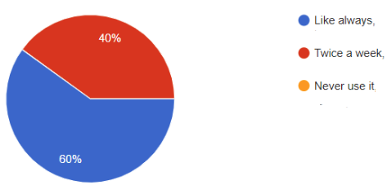

Are you planning to use our product ?

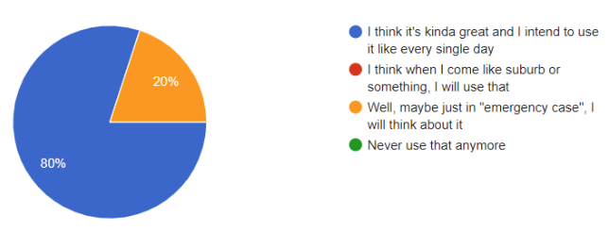

How are you most likely to recommend our product ?  
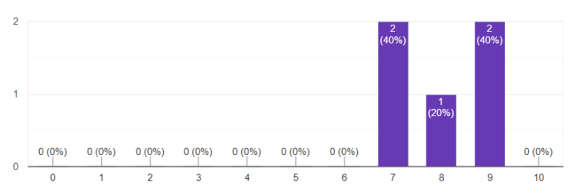

## Evaluate end user feedback from your IoT application

2. Review User feedback

### + how does your IoT meet the requirements

Well, Water planting Solution is us best product for urban population grow and traffic congestion   
With that you can plant trees with AUTOMATIC that make IOT Greater  
3. Purpose of this system

(https://www.youtube.com/watch?v=OL7TNx9RquE, n.d.)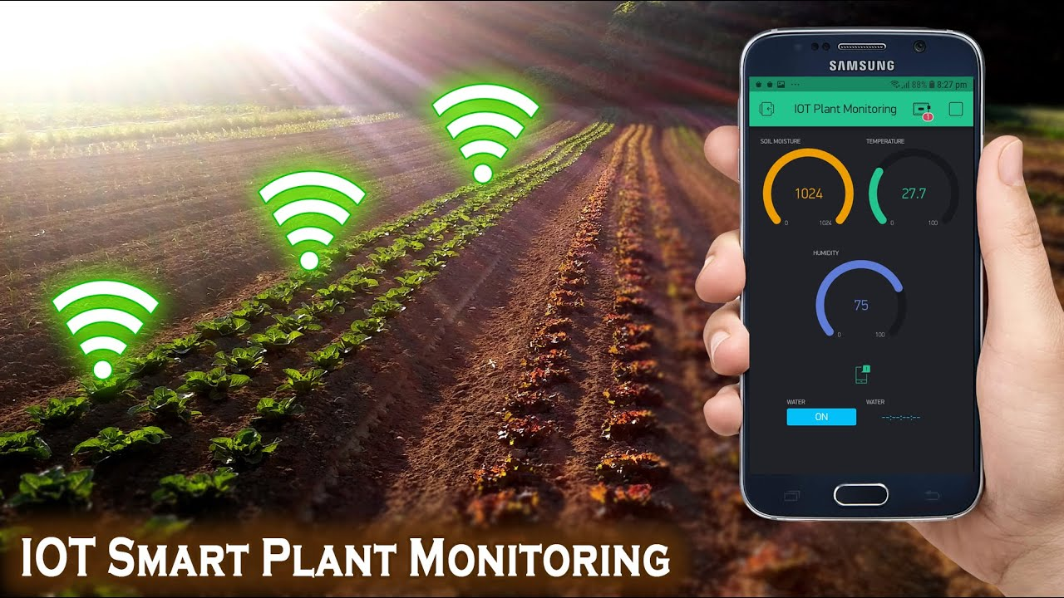

To plant Automatic as ROBOTIC

## System requirement

IOT board, with battery

Get datas real-time on plants

App must be needs for this IOT run to collects Data Real-Time and monitoring

## How this IOT Stuff affect us life

### + Feasibility (including technical, economy, and organization feasiblity)

Moderm life   
-Need Experience

Not all us know how to do Stuff faster without change Way to do

-Reduce Farmers

Human is source that waste human resource  
-Reduce Polution

Too much waste of water on dirt can protect by this IOT

-Optimize affective, speed and cost

Low cost is better   
Affective very usefull for plant trees to harvert FASTER

### + Ability to improve

Enviroment   
We need to reduce Polution as possible like 43 cacbon dioxit and lowered time consuming around 30% for everyone

## Conclusion

The key to perfect Water Plant Solution is making current technology better with available Technology like IOT, Big Datas, machine learning and cloud Computing   
Smart city is evoling everyday and becoming a golden age

We need to find a right team of trustworhty developer to solve problem for build success business toda